Library Meeting Minutes
Tuesday, 10/15/2024

Attended at Hornell Public Library: Submitted by G. Kelleher
Garrett McGowan – BOT President
Mike McCumiskey – BOT Vice President
Joe Liberto – BOT Chief Finance Officer
Gary Kelleher – BOT Secretary
Norm Ellis
Holly Hogan
Denise Chilson – Director
Excused:
Alex Hoffman
Pat Moore
Kate Santelli

Regular meeting called to order at 5:03pm

Secretary’s Minutes:
- Motion made to approve September’s minutes by Garrett, seconded by Norm. Approved unanimously.

Director’s Report:
- For the full Director’s Report, see Appendix A.

- Denise addressed a question about NYLA, which Eba and she will attend from 11/6 to 11/9.

- Hornell High School tours were held earlier this month and they went well.

- The shed cleanout went great – a huge thanks especially to Norm for all the improvements to the sheds (i.e. shelving, chair racks, etc…)

- Music by Ben Ellis was wonderful!

- Alma de Mexico on 10/12 was great, but poorly attended…

- The 10/21 Common Council meeting will include a discussion on the Community Arts Center. Denise will attend, if anyone else is able to support, please do!

- The following IT Updates were discussed:
  - Verizon Wireless is tough to contact. Denise is waiting on replacement Hotspot activation.
  - Phones will be replaced the week of 10/21.

- Friends desperately need members. Denise has suggested they join NYLA.

- Brian Hildrith will try to attend one of our Board meetings by January 2025, which will count towards our annual training requirement.

- Sexual Harassment training requirement is due. The video link has been emailed to the Board. Once complete, stop in the Library (Denise’s office) to sign off that you completed it… Denise gave kudos to Norm on being the first to complete this training!

- Denise will be revisiting job descriptions with Eba soon.

- Discussion on Hotspot thefts, as well as other issues that potentially could involve law enforcement.

- Norm asked if the Board should revisit the electric sign out front to enhance publicity of Library events. The consensus was that this would be a benefit!

Financial Officer’s / Financial Committee’s Report:
- For the full Financial Report, see Appendix B.

- Joe reported that the Library is in a “great spot”! He went over his report, drawing particular attention to the fact that the Mary Beth Smith Fund has matured, and that the tax levy is due to come in next month.

- Motion made by Joe, seconded by Garrett, to pay the Library’s bills for the month. Approved unanimously.

- Denise asked the Finance Committee to look over the Library’s current Fiscal Policy and make suggestions to the Policy Committee on updates / changes.

- Denise discussed the CPE Interlink estimate of $406.71 (for installation) and $180 per year (for Remote Station Monitoring). The Board approved this change.

- Denise discussed the need to digitalize our newspaper microfilm. There were some questions on this process, which resulted in the Board discussing possible solutions (i.e. a letter to Tom Golisano, a request for support from community members, etc…). Denise said she would look into some more information on what other libraries in STLS have done regarding this effort (i.e. Elmira or Corning). The Board agreed to revisit this topic soon…

Personnel Committee Report:
- Motion made by Holly, seconded by Norm, to make the following staff pay changes based on Denise’s suggestions:
- Move Eba Klindt to $22 per hour effective October 15, 2024.
- Move Christine Stewart to $22 per hour effective October 15, 2024.
- Move Bethany Diehl and Jazmine Sims to $18 per hour effective October 21, 2024.
- Start Vanessa’s (Library Programming Assistant position)replacement at $18 to $20 per hour.
Approved unanimously.

- Motion made by Holly, seconded by Norm, to move Kelly from 19.75 hours to 29.75 hours, effective October 21, 2024. Increase Kelly Markel’s hourly rate from $15.00 to $15.50, effective January 1, 2025. Approved unanimously.

- Motion made by Norm, seconded by Gary, to move minimum wage candidates to a starting wage of $16 per hour effective January 1st, 2025. Approved unanimously.

- Denise’s evaluation was shared. Denise thanked the Board for their comments on the evaluations.

Motion made by Joe, seconded by Norm, to go into Executive Session at 5:51pm. Approved unanimously.

Motion made by Gary, seconded by Holly, to return to Regular Session at 5:57pm. Approved unanimously.

President McGowan shared with Denise the decision to increase her salary to $65,000 per year, Effective retroactively September 13, 2024.
Building Committee Report:
- Norm reported:
  - That he spoke with Denise regarding what Constructive Aid Grant monies should fund, including but not limited to rear double door replacement, a new generator and possibly replacement of the downstairs front double doors being replaced as well.
  - Norm also spoke on the shed leakage problem, stating that he believes it is probably flooding from below rather than a roof leak. The possibility of putting gutters on the shed to help with pooling water under the shed was also discussed. Norm will continue to look into options and report back…

- Garrett spoke on Denise’s concerns regarding her office space needing improvements. The Board was supportive of these improvements, although Denise said this would most likely be a spring project on account of how busy they are right now…

Friends of the Library Report:
- A membership drive is desperately needed!

- Mike asked about an interested party that he was aware of, inquiring if they had reached out to Friends yet.

Outreach Committee Report:
- Gary reported that “Homebound Books” is ongoing with little change from previous months. Gary also shared that Denise and he will be meeting with a DHPSNY representative on Saturday, November 2nd in the History Room to get some feedback and suggestions on how to best move forward with the preservation and accessibility of those resources.

- Denise shared that she is considering combining the Homebound Books delivery with the current Nursing Home deliveries in the near future.

Policy Committee Report:
- Motion made by Garrett, seconded by Gary, to adopt the following revised or new policies as written and shared via email:
  - Wifi Hotspot Borrowing Policy
  - Video Surveillance Policy
  - Art Exhibit and Display Policy
  - Artist Exhibit Release of Liability Form
Approved unanimously.

- Joe reiterated that the Finance Committee would be looking over the current Fiscal Policy with recommendations to the Policy Committee on appropriate changes.

Old Business:
N/A

New Business:
N/A

The next Board meeting will be on Tuesday, November 19th at 5:00pm in the Hand-Saxon Room.

Motion made to adjourn at 6:16pm. Moved by Garrett, seconded by Joe. Approved unanimously.
Appendix A:

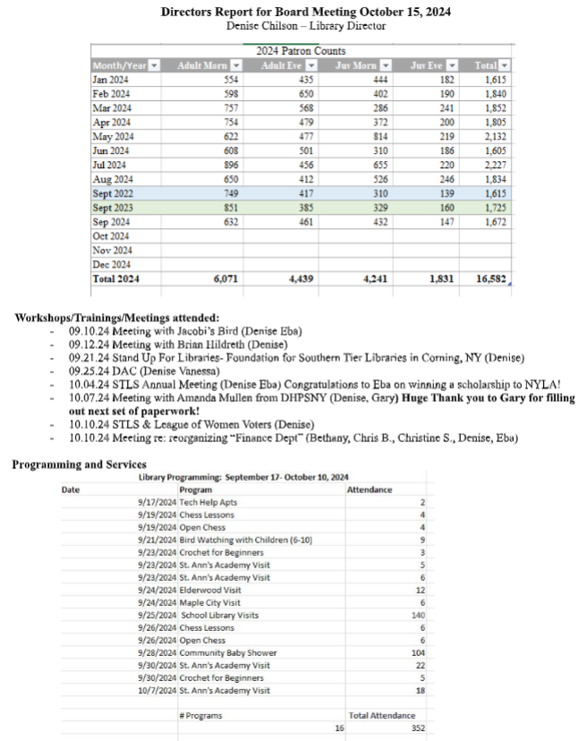

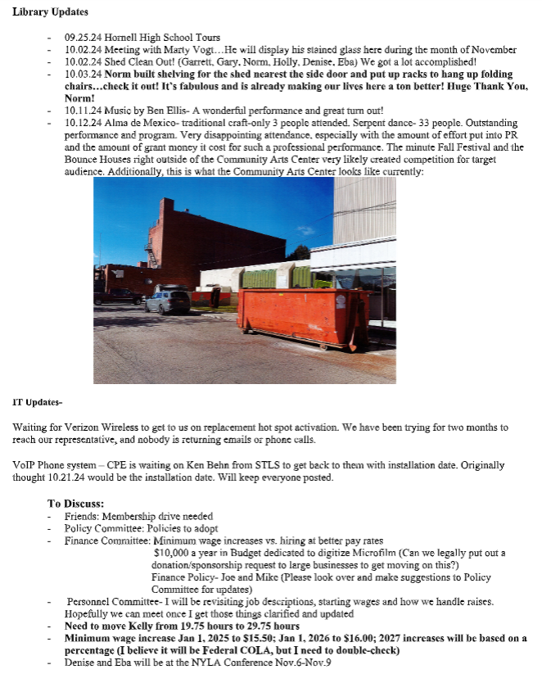

Appendix B:

