Request for Reconsideration of Library Materials Form

Introduction:
This form is in reference to the Challenge to Library Materials Policy and should be made available to any resident who would like the library to remove an item from the collection. Requests for Reconsideration may only be filed by residents of the Library’s service area. The Library will not process requests, and the Library Board will not hear requests from individuals who live outside the Library’s services area.

Please fill out the following form completely and mail to the Library Director, Hornell Public Library, 64 Genesee Street, Hornell, New York 14843.

Name: _________________________________________Date________________________
Address: ____________________________________________________________________
City: ____________________________________________State____________ZIP________
Phone: _____________________E-Mail __________________________________________
Do you represent yourself? ______ An Organization? _______________________________
Resource on which you are commenting:
Book ____Video/DVD____ Audiobook_____ Multi-media Kit ______ e-Book _____ Electronic information/network (please specify) ______________ Other (please specify) _____________
Title: _______________________________________________________________________
Author/Producer: ______________________________________________________________
Library owning this title: ________________________________________________________
What brought this title to your attention? __________________________________________________________________________________________
Did you read, view, or listen to the entire work? If no, what parts? ____________________________________________________________________________________________________________________________________________________________________________________
What do you believe is the theme of this title? ____________________________________________________________________________________________________________________________________________________________________________________
What specifically concerns you about this title? Please cite pages, scenes, items, etc. ____________________________________________________________________________________________________________________________________________________________________________________________________________________________________________________________
Are there, in your judgment, any positive elements in this title? Please describe: ____________________________________________________________________________________________________________________________________________________________________________________
Will you share any reviews of this title that support your point of view?__________________________ ________________________________________________________________________________________________________________________________________________________________________
Are there resources you suggest to provide additional information and/or other viewpoints on this topic? ____________________________________________________________________________________________________________________________________________________________________________________________________________________________________________________________
Signature:________________________________________
-------------------------------Official Library Use Only Below this Line----------------------------------------
Reconsideration action: ____________________________________________________________________________________________________________________________________________________________________________________________________________________________________________________________Date request received: ____________________
Findings of Reconsideration Committee: ___________________________________________________
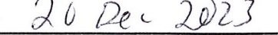
1____________________________________________________________________________________________________________________________________________________________________________________________________________________________________________________________ Date response sent to patron: ______________________
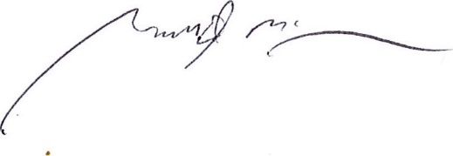
Adopted by the Hornell Public Library Board of Trustees,__________ ______________.

Garrett McGowan, President of the Board of Trustees

