PUBLIC COMMUNICATIONS POLICY

The Library Board of Trustees has a responsibility to promote public awareness of library services and programs, to develop public understanding and support of the library and the vital role it plays in the support of community well-being.

The Board of Trustees recognizes that effective public relations involve every person who has a connection with the library. The Board urges its own staff, volunteers, and friends to remember that they represent the library in every public contact and that professionalism and good service enhances good relations.

Official statements to the public and media will be made by the Library Director or the Board President in consultation with the Library Director. If anyone other than the Library Director or Board President must provide the public with information, such information will be reviewed and approved by the Library Director and Board President before its release.

The Board of Trustees will designate the official newspaper to be used for all public announcements at its annual Organization Meeting each year.

Social media platforms, including mass email communication services, play an important and active role in library communications. Designated library staff are responsible for posting information to all library-subscribed social media sites. Staff will adhere to the board-approved Social Media Policy when sharing information or images. Staff in consultation with the Library Director manage overall social media content. The library will not answer questions pertaining to Library Board matters through social media. These questions should be directed to the Library Board during Public Comment at a regular meeting.

Library staff and trustees are entitled to a safe and protected work environment both within the library building and online. Online communication that is sent or received by staff and trustees shall fall under the library’s workplace environment policy. Communication, specifically from the public, sent to staff or trustees that contains concerning, harassing or threatening language will be handled by the Library Director in discussion with the Board President. All incidents that pose a risk to human well-being will be documented and reported to the authorities.

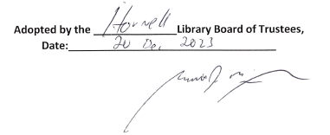

Garrett McGowan, President of the Board of Trustees

