PUBLIC COMMENT POLICY

The Hornell Library Board of Trustees incorporates an opportunity for Public Comment during its regular board meetings in accordance with New York State’s Open Meetings Law. Residents of the Library’s service area may use this time during meetings to verbally address the Board. The Library Board reserves the right to determine the manner in which public comments are received to maintain a fair, respectful, and well-managed meeting. The following Rules and Procedures apply to the Library’s Public Comment section of the meeting Agenda:

Rules and Procedures for Public Comment
- Participants must sign in and identify community of residence
- Participants must be a resident of Hornell City School District
- Participants must have a valid Hornell Public Library Card
- Residents will be recognized in order of sign-in
- Residents will be allotted a maximum of 3-minutes to speak
- A resident can only speak once, and only use their 3-minutes to speak
- Residents must limit their comments to library-related matters
- A designated library trustee will preside over the meeting
- A designated trustee will introduce each resident and keep track of the time.
- The Library Board may limit the total amount of time allowed for Public Comment
- The Library Board may only listen to residents during Public Comment
- The Library Board may not address an issue, or answer questions during Public Comment
- The Library Board may not vote upon any issue raised during Public Comment unless specified on the agenda.

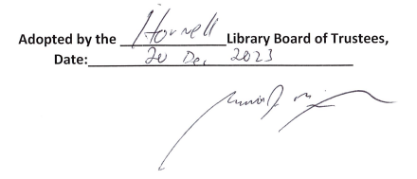

Garrett McGowan, President of the Board of Trustees

