COLLECTION MANAGEMENT POLICY

This Collection Management policy reflects the mission and core values of the Hornell Public Library, which includes the library’s Board of Trustees, Director, and Library Employees. In accordance with the guidelines included in the American Library Associations’ Library Bill of Rights, Freedom to Read and Freedom to View Statements, the Library maintains a collection of materials, both print and digital, that meet the diverse needs of our community.
It is an essential role of the Library to facilitate free access to a wide array of library materials, including possible controversial materials, to all community members. The Library, to the best of its abilities, strives to include a wide and inclusive spectrum of materials and topics. The inclusion of an item in the collection does not imply the Library’s endorsement of the author, publisher, or subject matter.

Responsibility for the selection of library resources is delegated to the Library Director by the Board of Trustees. At the discretion of the Director, qualified staff members are assigned selection responsibilities.
Selection criteria utilizes reputable, professionally reviewed literature and other sources in the selection, and purchase of new library materials. Additionally, the Library relies on trained library employees, who are trained through state and federal accredited institutions to maintain collections.

Selection criteria includes:
- Content
- Format
- Cultural Relevance
- Relation to current collection
- Price
- Demand

A selected work need not satisfy all criteria listed above to be included in the collection.
Library resources will not be labeled, marked or identified to show approval or disapproval of their contents. Resources are withdrawn from the collection in order to maintain their usefulness, currency, relevance and condition. Withdrawn resources may be sold, offered to other libraries or nonprofit organizations, recycled, discontinued or discarded.
Responsibility for monitoring a child’s access to resources rests with the parent or legal guardian.
The Library recognizes the importance of providing an opportunity for community members to request a reconsideration of library materials. Community members may follow the Library’s Challenge to Library Material’s Policy using the Request for Reconsideration Form to issue a formal concern. Requests for Reconsideration may only be filed by residents of the Library’s service area. The Library will not process requests, and the Library Board will not hear requests from individuals who live outside the Library’s services area.
Donations of materials or of funds for the purchase of materials, are welcome. The Library, however, accepts gift materials with the explicit understanding that those which are useful to the Library’s collection will be retained, and other materials may be disposed of in accordance with the Library’s policy. Suggestions of specific titles or subjects are welcome when memorial donations are given, but the final decision, based on the collection, rests with the Library. An appropriate book plate will be placed in each gift if requested by the donor.

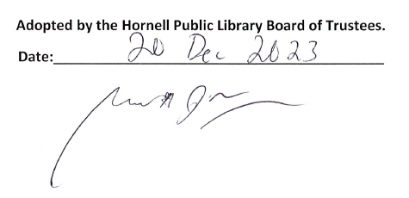
Adopted by the Hornell Public Library Board of Trustees.
Date:__________________________________________

Garrett McGowan, President of the Board of Trustees

