Challenge to Library Materials Policy
Introduction:
It is an essential role of the public library to make all, including possible controversial materials, freely available to all community members. This can mean that the views expressed in a library material conflict with a community member’s beliefs or perspectives. Having a policy to guide library employees, volunteers, and trustees in dealing with community challenges to a material ensures each complaint is dealt with fairly and every person in the library knows how to proceed.

Hornell Public Library supports all members of its community by collecting materials representing all viewpoints considering the Library’s Collection Management Policy. However, it is not the role of the Library to advocate for or endorse any particular idea, opinion, or point of view; nor will the Library or any of its employees, volunteers, or trustees act in loco parentis (as a parent to library patron – either adult or minor).
The Board of Trustees recognizes the importance of providing a procedure whereby opinions from the community regarding materials selected can be voiced. A request for reconsideration must be made in writing on forms provided by the Library. These forms are available upon request from the circulation desk and upon completion, should be delivered to the circulation desk, or mailed to the Hornell Public Library in care of the Library Director. Requests for Reconsideration may only be filed by residents of the Library’s service area. The Library will not process requests, and the Library Board will not hear requests from individuals who live outside the Library’s service area.

Upon receipt of the signed form, the Library Director will notify the Library Board that a form has been received, and review the information provided in the form to determine if the complaint requires further review, or if the materials should remain within the Library’s collection considering the Library’s Collection Management Policy. In consultation with the Library Board, the Library Director will inform the community member who submitted the form if the materials remain within the collection. The determination will be sent in writing through U.S Mail.
If the Library Director thinks further review is required, they will convene a committee with members of the Library Board and/or library employees.
The committee shall:
1. Examine the material in question, the issues raised, and the circumstances involved.
2. Decide to remove or retain the material in question.
3. Notify the American Library Association and the New York Library Association of the challenges.

The Library Director will inform the community member of the committee’s decision in writing through U.S. Mail.

Should the patron wish to appeal the decision, they may write to the President of the Board of Trustees to request a hearing by the Board as part of the Library’s Public Comment Policy. The Board will listen to the community member’s concerns during the meeting and make a decision regarding the challenged material at a meeting after the meeting where the hearing is held. The Library Board will inform the community member of the decision in writing through U.S. Mail.

Any further appeal must be made to the Commissioner of Education in Albany, N. Y.

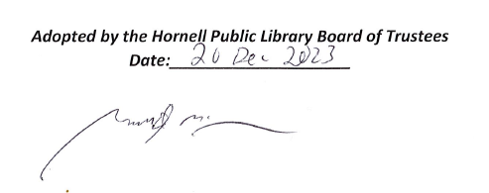
The Library Board places a limit on Challenges to Library Materials. The Library will only process a complaint form once every 36 months (3 years) for a specific Title or Author considering all material formats (format examples: book, eBook, audiobook, large print book, movie, or musical tracks). The Library Board’s decision is final.

Adopted by the Hornell Public Library Board of Trustees
Date:____________________

Garrett McGowan, President of the Board of Trustees

